|  |  |
| --- | --- |
| UC Name | **Customer Support Portal Access** |
| Summary | This use case involves users accessing the customer support portal or help desk for assistance with inquiries, issues, and account-related questions. |
| Dependency | None |
| Actors | **Primary Actor:** Registered User  **Secondary Actor:** Customer Support Agent |
| Preconditions | The user must be registered and logged into the bank management system.  The user must have an active account with the bank. |
| Description of the Main Sequence | User navigates to the "Customer Support" section of the bank management system.  System displays the customer support portal with options for live chat, email support, and phone support.  User selects the desired support channel (live chat, email, or phone).  **If live chat:**  System connects the user to a live chat session with a customer support agent.  User interacts with the support agent in real-time.  **If email:**  System opens a form for the user to fill out their inquiry or issue.  User submits the form, and system sends the email to the customer support team.  **If phone:**  System displays dedicated helpline numbers for different languages.  User selects the appropriate helpline number and calls for assistance. |
| Description of the Alternative Sequence | If the user's preferred language is not available:  User selects the closest available language option.  If necessary, user requests assistance in their preferred language through the selected language option. |
| Non-functional Requirements | The system shall offer language support for customer interactions in multiple languages.  Users shall be able to switch languages during an ongoing customer support session if needed. |
| Post Conditions | The user's selected language is used for all subsequent interactions within the customer support session.  These are two system requirements for the Customer Support module in the bank management system, outlined in the requested format. |

**Use case**

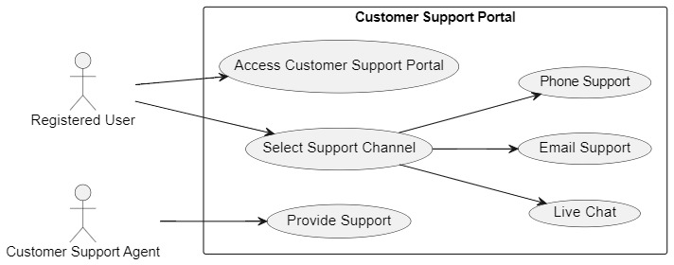

**Activity Diagram**

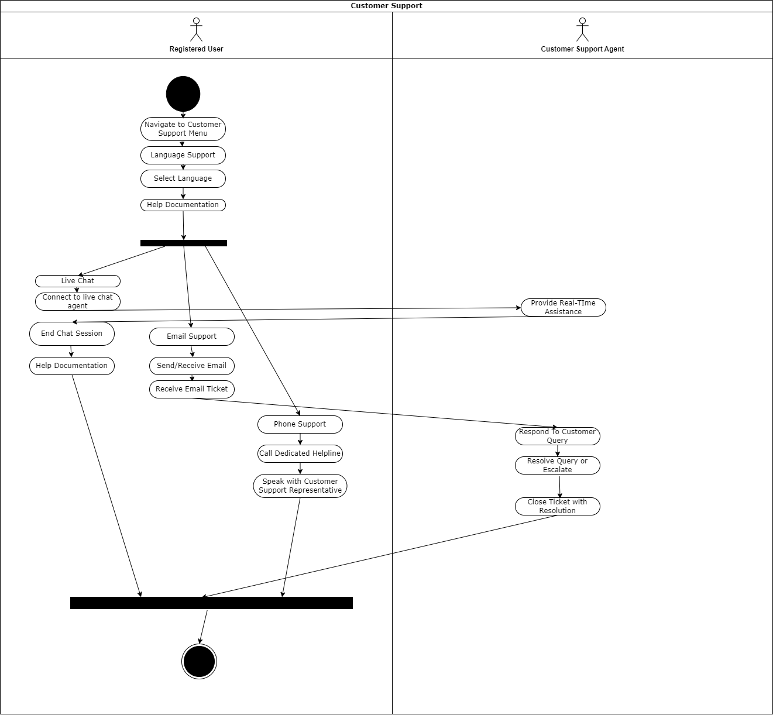

**Sequence Diagram**

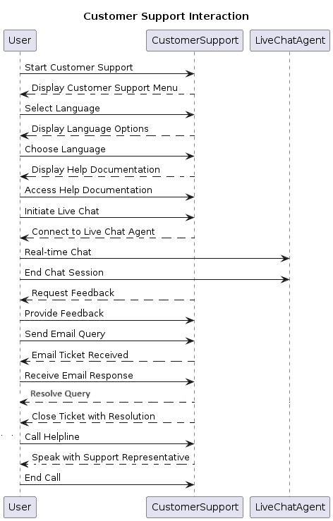

State Machine Diagram

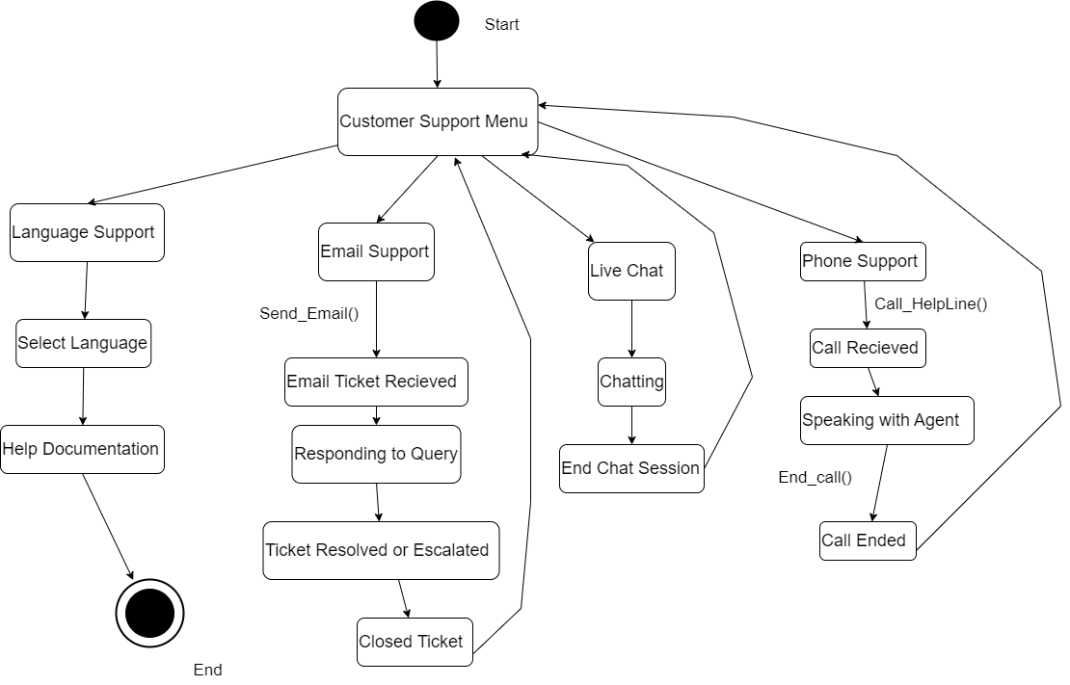

**Collaboration Diagram**

